# [[1, Efficient area-throughput tradeoff for FFT]]

Aspects of the present disclosure may include an efficient area-throughput tradeoff for Fast Fourier Transform (FFT) implementations, which may be significant in optimizing performance in various applications. The area and throughput may be characterized as parameters that can influence the overall efficiency of analog devices. By way of example, the tradeoff may be analyzed through mathematical modeling, where the throughput may correspond to the processing speed, while the area may represent the physical space occupied by the circuitry. The implications of this tradeoff may be further investigated to ensure that optimal configurations are achieved, potentially involving various design methodologies that may allow for enhanced performance without excessive resource consumption. Additionally, considerations may be given to the integration of wireless communication networks, where the efficiency in FFT processing may play a crucial role in data transmission and signal processing. This may result in advancements that may not only improve throughput but also reduce the area required for implementation, thereby enhancing the overall functionality of the devices involved.

# [[2, Inventors]]

Aspects of the present disclosure may include a novel approach to enhancing the efficiency of wireless communication networks. The proposed method may employ advanced modulation techniques that can significantly improve data transmission rates while reducing power consumption. By way of example, the system may utilize adaptive algorithms that may monitor channel conditions and dynamically adjust parameters to optimize performance. Furthermore, aspects of the present disclosure may also involve the integration of machine learning models that may predict network behavior and facilitate proactive management of resources. This may result in a more robust and resilient communication framework capable of supporting the increasing demands of modern applications. The implementation of these strategies may not only enhance user experience but may also contribute to the sustainability of wireless infrastructures.

# [[3, Introduction]]

Aspects of the present disclosure may include a Fast Fourier Transform (FFT) design that facilitates the exchange of throughput for area, potentially without increases in power consumption or latency. This innovative approach may allow for enhanced performance in various applications by optimizing the utilization of available resources. By way of example, it may be possible to configure the system to dynamically adjust throughput based on specific operational requirements, thereby maximizing efficiency. Additionally, the design may be capable of maintaining consistent performance metrics, which may be significant in applications where power efficiency is critical. The implications of this design may extend to various fields, potentially enabling advancements that may not have been achievable with prior solutions, thereby contributing to the ongoing evolution of technology in the relevant sectors.

# [[4, Problem Definition]]

Aspects of the present disclosure may include the implementation of a fully parallel, pipelined Fast Fourier Transform (FFT) in hardware, which is anticipated to achieve the highest possible throughput. In some aspects, it may be acknowledged that for certain applications, a slower design may be acceptable if it results in a reduced logic area, thereby optimizing resource utilization. The power efficiency associated with a fully parallel design may be retained even when throughput is traded for area, allowing for a balance between performance and resource consumption. This approach may involve the careful consideration of trade-offs, ensuring that the benefits of power efficiency are not compromised while still meeting application-specific requirements. By way of example, the design may be configured to adaptively manage throughput and area, which may be significant for applications requiring efficient signal processing.

# [[5, Prior Art]]

The prior solutions include multiplexing the input data along with twiddle factors, which may need to be stored in memory while regular multipliers are employed instead of constant multipliers. This approach may lead to a significant increase in power consumption due to the reliance on regular multipliers and multiplexers. In some aspects, when one operand of a multiplication is constant, the operation may be implemented with greater efficiency. Aspects of the present disclosure may include methods to optimize the multiplication process by leveraging constant multipliers, which may reduce power consumption and improve overall performance. Additionally, the potential for minimizing memory usage by eliminating the need for storing twiddle factors may be utilized, thereby enhancing the efficiency of the FFT.

# [[6, Proposed Solution]]

The present disclosure includes an examination of the DIF-FFT algorithm, wherein it is observed that all stages, with the exception of the first, may contain repeated and independent sub-problems. In this context, to the present disclosure implements the first stage in its entirety while addressing only one sub-problem from the second stage, in addition to the corresponding number of sub-problems from the subsequent stages. This approach may optimize the overall efficiency of the algorithm and may ensure that computational resources are utilized effectively. Aspects of the present disclosure may further involve considerations of how these implementations may correspond to improvements in processing speed and resource management within the FFT. By way of example, this methodology may also include strategies for minimizing redundant calculations, thereby enhancing performance metrics.

# [[7, drawing—was the tool not able to read it in order to come up with some description?

# Note: it may not be clear, but the description from slide 6 is actually referring to this figure on slide 9.]]

# [[8, Proposed Solution (continued)]]

The present disclosure includes a radix-4, 256-point FFT as a specific example of the proposed solution. In this design, the first stage is configured to compute a 256-sample result within the initial cycle, subsequently providing the first 64 samples to a pipeline including 2nd, 3rd, and 4th stages. The remaining samples are organized to be sent to the pipeline in groups of 64 over the following three cycles. Upon completion of all four groups, the data may be reordered to yield the final result. It should be noted that while a fully parallel design may accept a new input every cycle, this particular design may only accept a new input every four cycles, which may indicate a trade-off between throughput and input acceptance frequency. Aspects of the present disclosure may thus enhance the efficiency of data processing within the defined constraints.

# [[9, drawing—was the tool not able to read it in order to come up with some description?

# Note: it may not be clear, but the description from slide 8 is actually referring to this figure on slide 9.]]

# [[10, Proposed Solution (continued)]]

The present disclosure includes an innovative approach that may reduce the area required for implementation to ¼ for a very large radix-4 FFT, while also reducing throughput by the same factor. Minimal multiplexing may be required solely for the first stage, and all multiplications may involve one constant operand, which may enhance efficiency. Aspects of the present disclosure may achieve a favorable tradeoff between area and throughput, while retaining all other advantages associated with a fully parallel design. This design may not only optimize resource allocation but may also ensure that performance metrics are maintained, thereby providing significant benefits in applications involving digital signal processing.

# [[11, What do you think needs to be claimed]]

The present disclosure includes an implementation of the Fast Fourier Transform (FFT) algorithm, wherein only a portion of the further stages is implemented in hardware. Aspects of the present disclosure may involve the reuse of the hardware for these further stages to compute the full transform, which may enhance efficiency. The further stages may specifically include constant multipliers, where one operand remains constant, thereby facilitating a design that is power-efficient due to the absence of multiplexing. This approach may result in reduced power consumption while maintaining performance, suggesting that the proposed implementation may be well-suited for applications requiring efficient signal processing. By way of example, the configuration may be optimized to ensure that the benefits of hardware implementation are realized without compromising the overall functionality of the FFT algorithm.

# Extracted Images

Image from Slide 1:



Image from Slide 7:

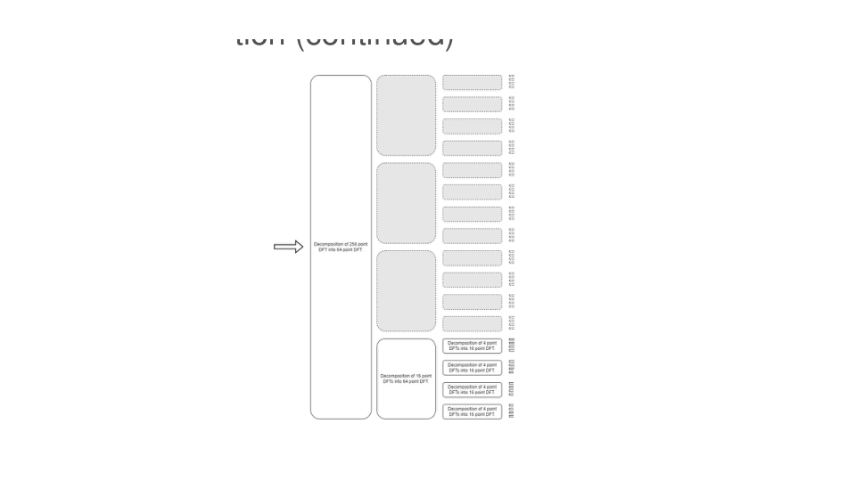

Image from Slide 9:

